Continuing education certificate
This certificate is awarded to
For your completion of
CDC Project Firstline, Module 2-Injection Safety.
Project Firstline is an Infection Control Initiative designed by the Centers for Disease Control and Prevention.
This course has been approved by the South Dakota EMS Program through the Office of Rural Health for 30 minutes of Continuing Education credit. Course Name: Injection Safety, Course Type: Specialty Course, Course # SDCE2288, Course Location: SD Foundation for Medical Care, Course Start Date: 11/24/2021, Course End Date: 01/01/2024

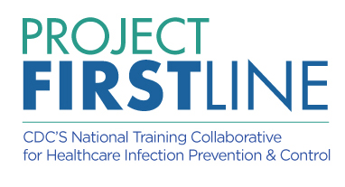
Cheri Fast RN
South Dakota Project Firstline

