Scavenger Hunt Instructions
This scavenger hunt was developed to promote awareness of Project Firstline, the new materials, and posters. By participating in the scavenger hunt, participants will gain knowledge of basic infection control.

- The posters, instructions and quiz are available on our website.
www.sdprojectfirstline.org
- It is recommended that the scavenger hunt be available within the facility for a period of at least one week.
- Hang the posters throughout the facility. Some recommended locations include in the breakroom, cafeteria, elevator, locker room and hallway.
- Distribute the quiz to employees/staff. The answers to the quiz will be located on the posters that are throughout the facility. (2 questions per poster)
- Instruct staff to return the quiz to supervisor once completed.
- Supervisor will then report to SD Project Firstline:
How many took quiz?
Who participated? (RN, EVS, Dietary, etc.)
All staff quiz answers to questions 19-21

Posters Used: Print one of each and one attachment one poster.
- Germs live in Water and Wet Surfaces
https://www.sdprojectfirstline.org/_files/ugd/468cf6_77b8a76d0e224b21a069a52909f0a427.pdf

- Germs live on Dry Surfaces
https://www.sdprojectfirstline.org/_files/ugd/468cf6_5b7b0b3fe9324a4481392dbee918a52a.pdf

- Germs live in Dirt
https://www.sdprojectfirstline.org/_files/ugd/468cf6_e1ac1e6cf7364d95989d5bdeae945dfe.pdf

- Germs live on Devices
https://www.sdprojectfirstline.org/_files/ugd/468cf6_8fc3beec46e74ef3b90f0633b91e773d.pdf

- Germs live on Skin
https://www.sdprojectfirstline.org/_files/ugd/468cf6_db3b334fc6ed4445b0792e65b26deff1.pdf

- Germs live in Respiratory System
https://www.sdprojectfirstline.org/_files/ugd/468cf6_a473fdd4fc544221b8dd2adbe86235e2.pdf

- Germs live in Blood
https://www.sdprojectfirstline.org/_files/ugd/468cf6_0ac7a2ce51c141a8bb38f8d9ebcefd5b.pdf

- Germs live in Gut
https://www.sdprojectfirstline.org/_files/ugd/468cf6_95e3920435cf40e9a18a6ea74bb7d55f.pdf

Scavenger Hunt Quiz
- Please find our Project Firstline poster with QR code, scan it, and enter your name and email address under trainings.

- Name one interactive video on our website, www.sdprojectfirstline.org.

- Name three PPE items used to reduce the risk of infection related to germs in water and wet surfaces.

- T/F: Using PPE, is a key infection control action to reduce infection risk.

- Name three “high-touch” surfaces that could carry germs in a healthcare setting.

- T/F: Rotavirus is an example of a germ that commonly lives on dry surfaces.

- What is one way to reduce risk of infection from germs that travel in the air?

- T/F: Construction, big or small, can release germs into the air that increase the risk of infection in patients with weakened immune systems.

- What is an example of a device shared by patients that could be a risk for germ spread in healthcare setting?

- T/F: Staphylococcus aureus (“Staph” including MRSA) is germs that commonly lives on devices and cause infection.

- Name one of the germ that commonly lives on skin.

12. T/F: Healthcare tasks can involve breaking the skin, which breaks down the body’s defenses and increase the risk for, germs to spread.
13. Name one healthcare task involving the respiratory system that could put a patient at higher risk for a respiratory infection.
14. T/F: Germs are more likely to spread in spaces with poor ventilation.
15. Name one healthcare task that can put a healthcare worker higher risk of getting an infection from germs that can be found in blood.
16. T/F: Hepatitis B is the only type of hepatitis that can cause infections in the blood.
17. What germs live in the gut and are considered part of a healthy immune system?
18. Did you find this activity useful?
19. What is one thing you learned from this activity?
20. Would you recommend SD Project Firstline to a co-worker/friend?

Scavenger Hunt Quiz (Answer Key)
Please find our Project Firstline poster with QR code, scan it, and enter your name and email address under trainings. (Attachment 1)
On our website name one interactive video on our website, www.sdprojectfirstline.org. Fidgeting Felix or Diarrhea Dilemma
Name three PPE items used to reduce the risk of infection related to germs in water and wet surfaces. Gloves, gowns, eye protection
T/F: Using PPE, is a key infection control action to reduce infection risk. True
Name three “high-touch” surfaces that could carry germs in a healthcare setting. There are many high-touch surfaces in healthcare. A few examples include bed rails, door handles, and light switches they also include countertops, bed curtains, floors
T/F: Rotavirus is an example of a germ that commonly lives on dry surfaces. True
What is one way to reduce risk of infection from germs that travel in the air? Cleaning and disinfection, ventilation, using barriers and other types of construction containment
T/F: Construction, big or small, can release germs into the air that increase the risk of infection in patients with weakened immune systems. True
What is an example of a device shared by patients that could be a risk for germ spread in healthcare setting? There are many devices shared in healthcare that can spread germs. An example of an item from the poster is a pulse oximeter
T/F: Staphylococcus aureus (“Staph” including MRSA) is germs that commonly lives on devices and cause infection. True
Name one of the germs that commonly lives on skin. Staphylococcus aureus (“staph,” including MRSA), Streptococcus (strep), Candida (including C. auris)
T/F: Healthcare tasks can involve breaking the skin, which breaks down the body’s defenses and increase the risk for, germs to spread. True
Name one healthcare task involving the respiratory system that could put a patient at higher risk for a respiratory infection. There are many risks in the healthcare setting that put healthcare workers at risk for a respiratory infection. A few examples from the poster are oral care (toothbrushing), CPAP used for sleep apnea, Intubation, giving nebulized medication
T/F: Germs are more likely to spread in spaces with poor ventilation. True
Name one healthcare task that can put a healthcare worker higher risk of getting an infection from germs that can be found in blood. There are many risks in the healthcare setting that put healthcare workers at risk for a getting an infection from blood. A few examples are putting in an IV, giving an injection, surgery, and procedures, changing soiled laundry
T/F: Hepatitis B is the only type of hepatitis that can cause infections in the blood. False
What germs live in the gut and are considered part of a healthy immune system? Bacteria and some yeasts

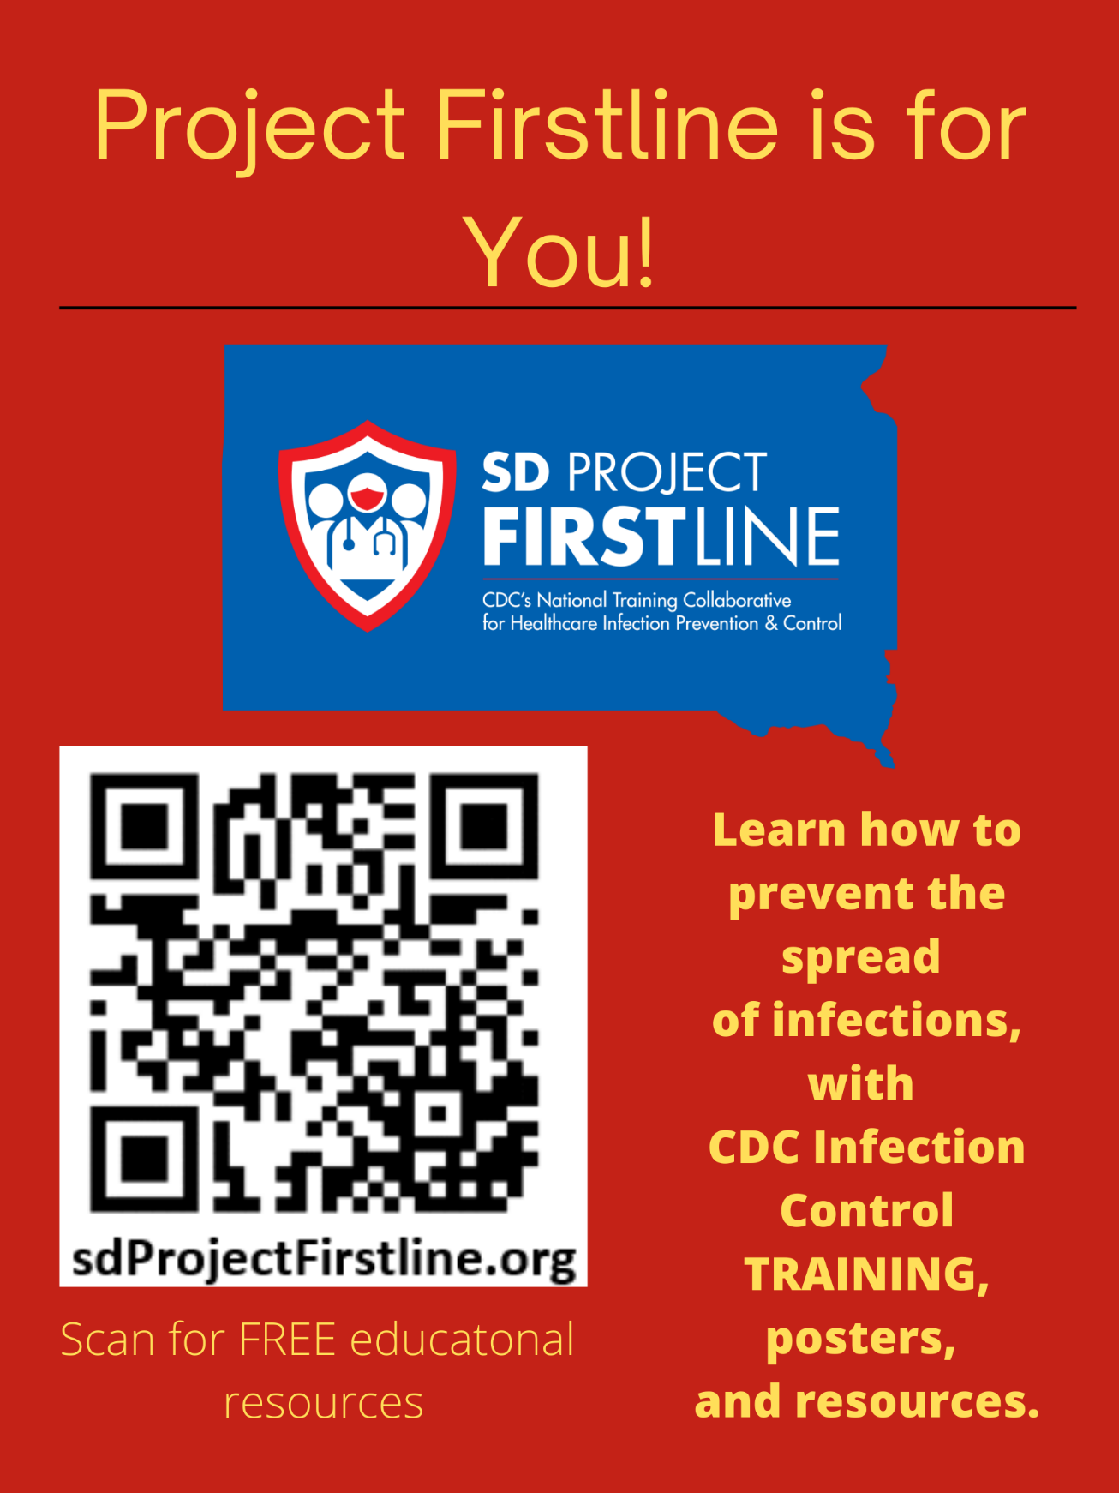
ATTACHEMENT 1

